2018 AREA Scholarship Recipients

Abram Qiu, the son of Haibo Qiu and Lihua Ju, received the top AREA scholarship of $5000 for outstanding academic achievement and community involvement. He will enter Rice University this fall seeking an Engineering degree. While attending Marin High School, Abram achieved the “Student of the Month” award, volunteered at a Hospital and non-profit health care clinic and was a violinist in the All Region Symphony Orchestra. Abram is a national finalist in the 2018 National Merit Scholarship Program and achieved a perfect ACT score.

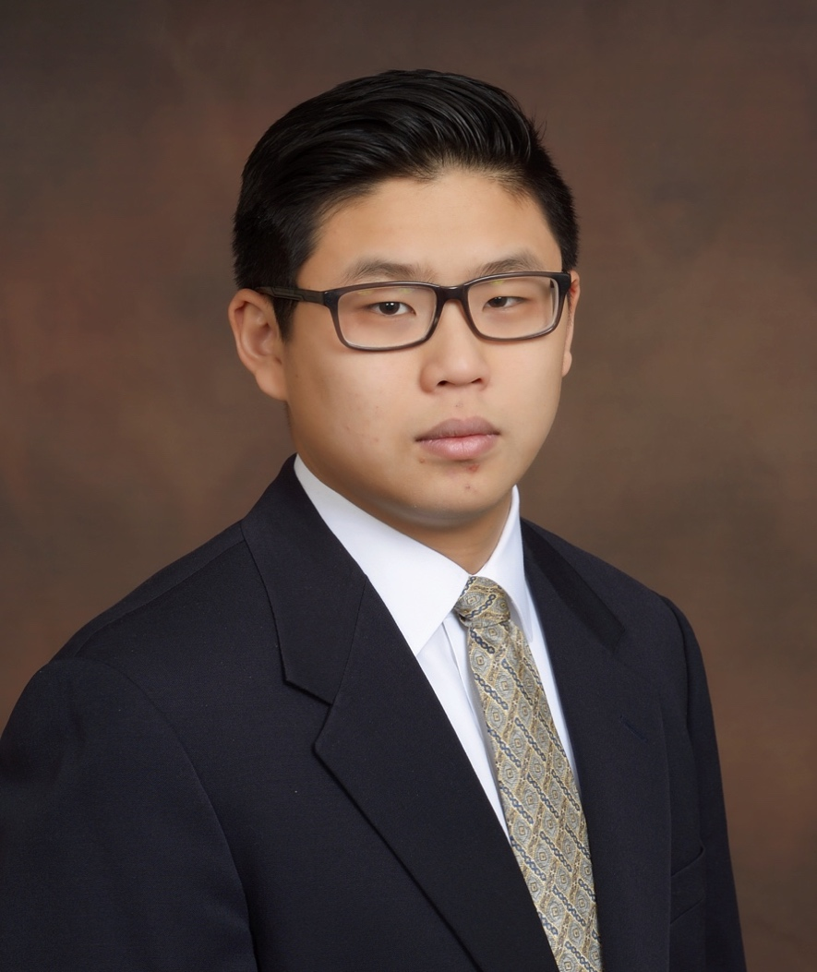

Hannah Lei, the daughter of I-Chen Chen and Michael Lei, received one of two $5,000 scholarships awarded. She plans to major in computer science at one of the four prestigious universities where she has been accepted. Hannah maintained a 4.0 GPA throughout high school. She received the Presidential Volunteer Service Award for three years, participated in city government through the Arlington Youth Council and played in the All Region Symphony and All State Orchestra. She is valedictorian of her senior class



Rohan Vemu is the son of Srinivas Vemu. He was awarded the top $3,000 scholarship. He will attend the University of Pennsylvania, majoring in Bioengineering.
Rohan Is an Eagle Scout, was on the Honor Roll for three years and served as a Research Intern at the Universities of Pennsylvania and Washington. In addition to his scholastic achievements, Rohan played the violin as an All State Texas Musician.

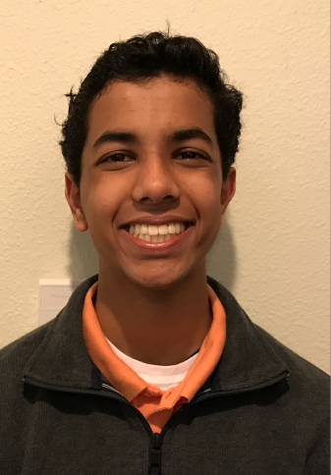

Audrey Wall is the daughter of Michael Wall and a $3,000 scholarship awardee. A member of the National English Honor Society, she plans to major in General Sciences at the University of North Georgia at Dahlonega. She achieved a 4.1 GPA as well as serving as Cadet Captain in her Junior Reserve Officer Training Corps (JROTC). Audrey’s goal is to become a Pediatric Nurse Practitioner in a military hospital.



Megan Brett, the daughter of Kevin Brett, was awarded a $3,000 scholarship. She will be a Business/Pre-Dental major at Texas A&M University. Megan is the Captain of the Varsity Golf Team, a member of Student Council and the National Honor Society. To support her dream of becoming an Orthodontist, Megan maintained a 4.7 GPA. She wants to practice in third world countries in order to bring much needed dentistry to those in need.

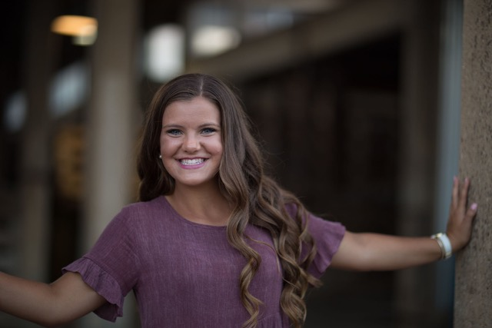

Jeremy Lee is the son of Andrew and Vicki Lee and recipient of a $3,000 award. He is an Eagle Scout and member of the Mountain View College Honor Society, and the Phi Theta Kappa Honor Society. He has taken five college level courses while attending High School. Jeremy plans to major in Pre-Law at one of the four prestigious Universities where he has been accepted.

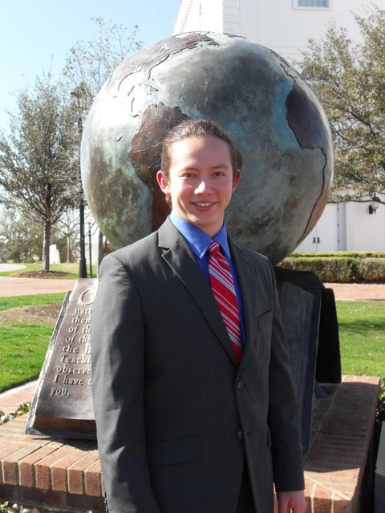

Elise Tyler, the daughter of Christopher Tyler, is the recipient of a $3,000 scholarship. She is a member of National Honor Society, International Thespian Society and German Honor Society. She managed the Boys Varsity and Junior Varsity Soccer Teams, tutored Middle School students and played in the school band and orchestra. Elise is a Pharmacy major who plans to attend Regis University in the fall.



Joleen Ozias Wright is the son of Terri Wright and a $3,000 scholarship winner. He is a Mechanical Engineering major and plans to attend Sul Ross State University. Ozias was on the Honor Roll throughout high school and volunteered at the Central Texas Boys and Girls Club. He was named the 2017 Offensive Most Valuable Player as a member of the football team as well as playing on the Central Texas All Star team. Ozias is certified by the National Institute for Automotive Service in Automotive Technology.



Brooke Christoffersen, the daughter of Shawn Waldrop, was awarded a $3000 scholarship. She will attend Dallas Baptist University studying Music Education this fall.
Brooke Volunteered for the National Honor Society, served in student government and achieved an Advance Placement Scholar Award. For two consecutive years, she was honored as an Outstanding Performer in the solo and ensemble contests. She aspires to be a music teacher.



Sebastiano Porter, the son of Gregory Porter, was awarded at $3000 scholarship. He will major in Biology at Point Loma Nazarene University in the fall. Sebastiano is a member of the National Honor Society and the National Society of High School Scholars. In addition to his academic achievements, he volunteers at the North Texas Food Bank and the Duncanville Recreation Center. Sebastiano aspires to attend Medical School.



Tyrell Frederick, the son Bettina Ciciriello-Frederick, was awarded a $3000 scholarship. He plans to major in History at Sacramento State University. Tyrell served in student government as well as participating in the Model United Nations. He was awarded Certificates of Excellence and Recognition from the San Bernardino Superintendent of Schools and the California Legislature Assembly. He hopes to serve in the United States Air Force.

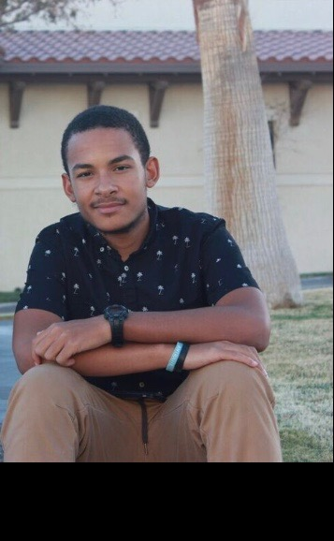

Leona Walton, the daughter of Kristen Schmied, was awarded a $3000 scholarship. She will attend Florida State University as a Biology major. She graduates Summa Cum Laude and is a member of the National Honors Society. She is a volunteer and a member of the Cross Country and Track and Field Team. She attended medical classes at Florida State University during the summer and aspires to be a surgeon.

